ASSESSMENT TOOL 1
COURSE NAME: COMPUTER VISION
COURSE CODE: ITA05
- YAVANIKA S
192521258

- 1.A camera captures an image that appears blurred due to improper sampling.
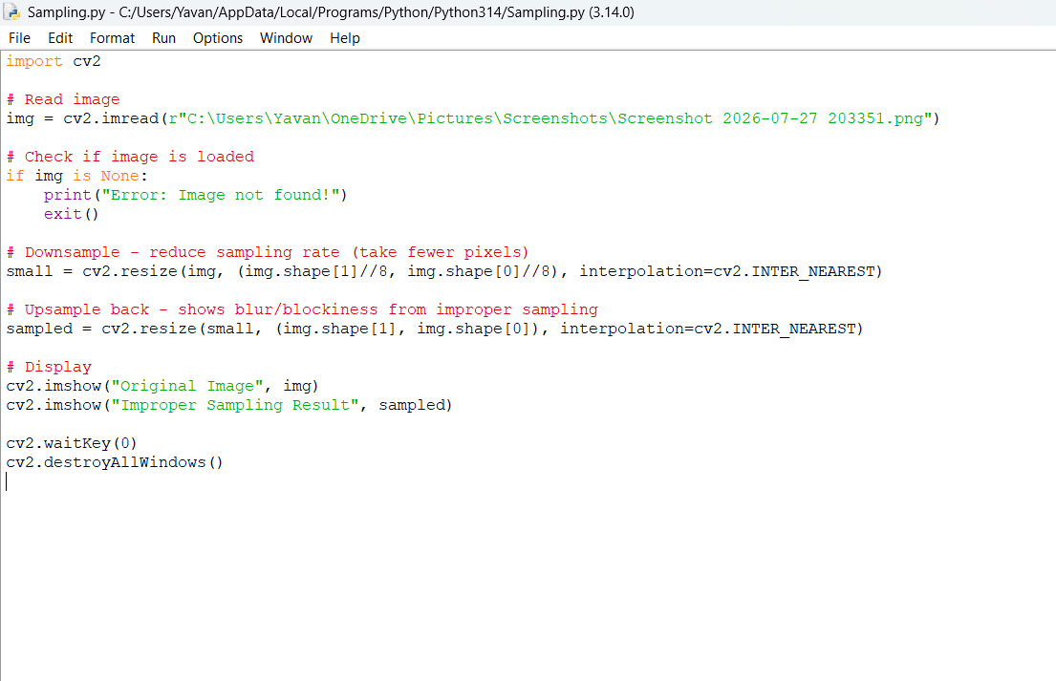
Write a Python program to demonstrate image sampling.
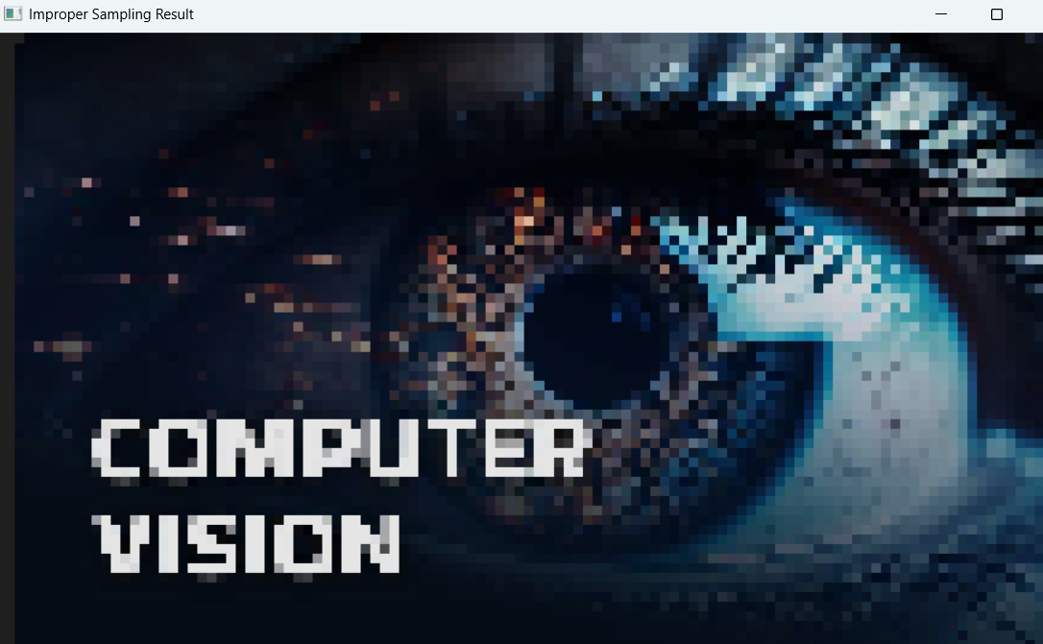
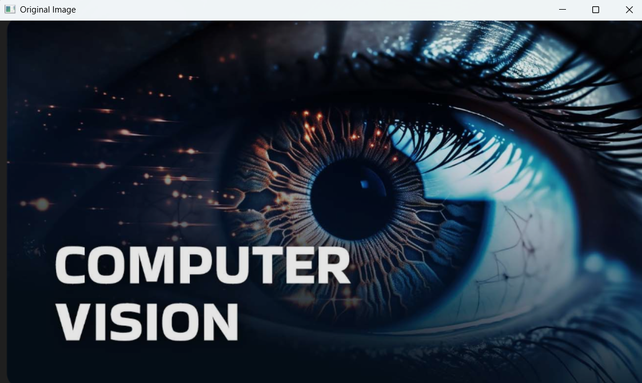

- 2.A real-world scene is captured under low-light conditions.
Write a Python program to enhance the low-light image.
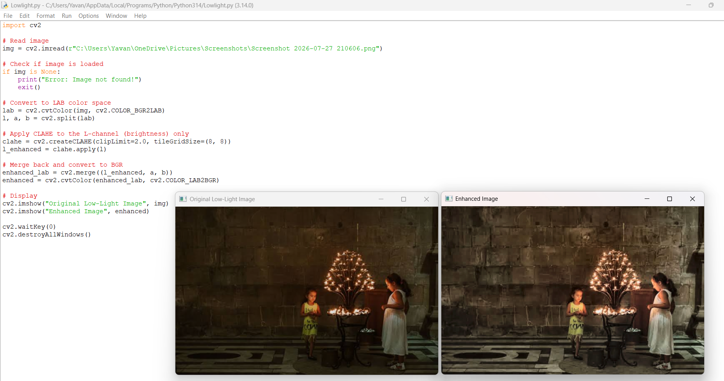

- 3.An automated surveillance system monitors moving objects.
Write a Python program for motion detection.
